Gesture Recognition Case Study

Team Members: Vagdevi PedalenkaArjun Ashok Kumar

Problem statement: Recognize five different gestures performed by the user which will help users control the RV without using a remote.

The gestures are continuously monitored by the webcam mounted on the TV. Each gesture corresponds to a specific command.

1. Thumbs up: Increase the volume
2. Thumbs down: Decrease the volume
3. Left swipe: 'Jump' backwards 10 seconds
4. Right swipe: 'Jump' forward 10 seconds
5. Stop: Pause the movie

We tried multiple models – Conv3D, CNN+RNN and also tried with transfer learning. The following is a list of models we trained with the results and explanation.

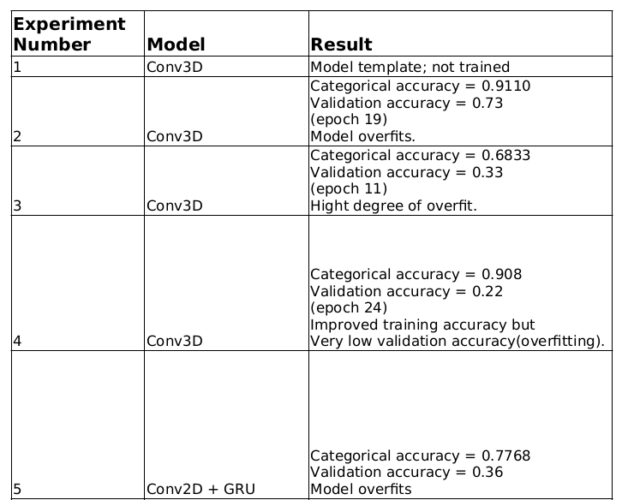

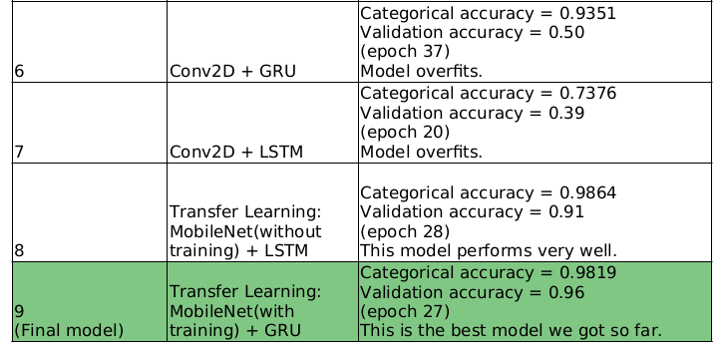

The model trained using mobileNet + GRU performed the best – good train and validation accuracy and no signs of overfitting. Hence, we can use this as the final model.